...in six days the LORD made heaven and earth,
the sea, and all that in them is,
and rested the seventh day:
Exodus 20:11
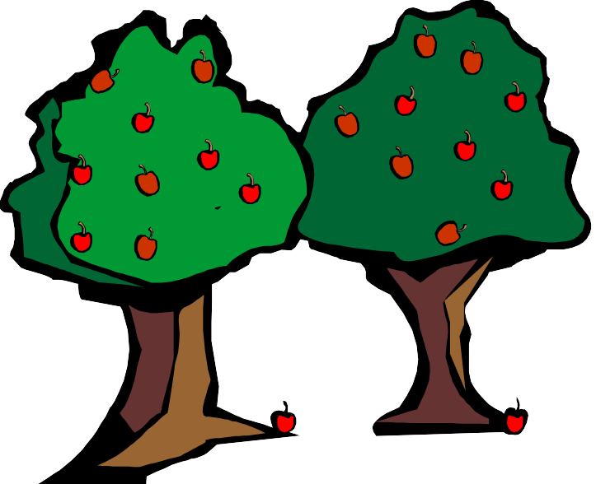
God divided the light from the darkness.
Genesis 1:4
God divided the waters from the waters
Genesis1:6

Genesis
God made the dry land, trees, grass, and plants
Genesis 1:10-11

God made two great lights and the stars
Genesis 1:16
God made the fish and the birds Genesis 1:21
God made land animals and people Genesis 1:25, 27
So God created man in His own image, in the image of God created He him; male and female created He them.
Genesis 1:27

