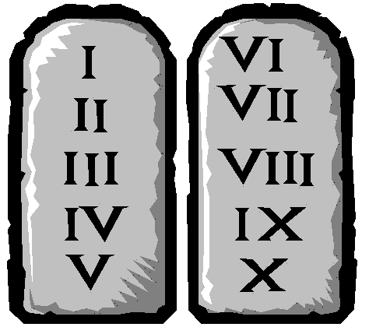

Good works

Baptism
Church membership
Hell
Heaven with God
1. No other gods
2. No graven images
3. Do not take God’s name in vain
4. Keep the sabbath day holy
5. Honor thy father and mother
6. Do not kill
7. Do not commit adultery
8. Do not steal
9. Do not bear false witness
10. Do not covet any thing that is thy neighbor’s

Exodus 20:1-17
Romans 3:10, 23 As it is written, There is none righteous, no, not one: For all have sinned, and come short of the glory of God;

Romans 6:23 For the wages of sin is death...

Romans 3:20 Therefore by the deeds of the law there shall no flesh be justified in his sight: for by the law is the knowledge of sin.

Galatians 2:16 ... a man is not justified by the works of the law, but by the faith of Jesus Christ, even we have believed in Jesus Christ, that we might be justified by the faith of Christ, and not by the works of the law: for by the works of the law shall no flesh be justified.

Ephesians 2:8-9 For by grace are ye saved through faith; and that not of yourselves: it is the gift of God: Not of works, lest any man should boast.
Revelation 21:8 But the fearful, and unbelieving, and the abominable, and murderers, and whoremongers, and sorcerers, and idolaters, and all liars, shall have their part in the lake which burneth with fire and brimstone: which is the second death.
John 14:2-3
In my Father’s house are many mansions: if it were not so, I would have told you. I go to prepare a place for you. And if I go and prepare a place for you, I will come again, and receive you unto myself; that where I am, there ye may be also.

Psalms 9:17 The wicked shall be turned into hell, [and] all the nations that forget God.

