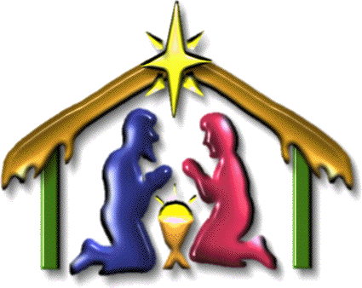
John 1:14 And the Word [Jesus] was made flesh, and dwelt among us, (and we beheld his glory, the glory as of the only begotten of the Father,) full of grace and truth.

John 1:10-11 He was in the world, and the world was made by him, and the world knew him not. He came unto his own, and his own received him not.
Isaiah 7:14 Therefore the Lord himself shall give you a sign; Behold, a virgin shall conceive, and bear a son, and shall call his name Immanuel.

Matthew 1:21-23 And she shall bring forth a son, and thou shalt call his name JESUS: for he shall save his people from their sins. Now all this was done, that it might be fulfilled which was spoken of the Lord by the prophet, saying, Behold, a virgin shall be with child, and shall bring forth a son, and they shall call his name Emmanuel, which being interpreted is, God with us.

Isaiah 9:6 For unto us a child is born, unto us a son is given: and the government shall be upon his shoulder: and his name shall be called Wonderful, Counsellor, The mighty God, The everlasting Father, The Prince of Peace.

1 John 4:14 And we have seen and do testify that the Father sent the Son to be the Saviour of the world.

