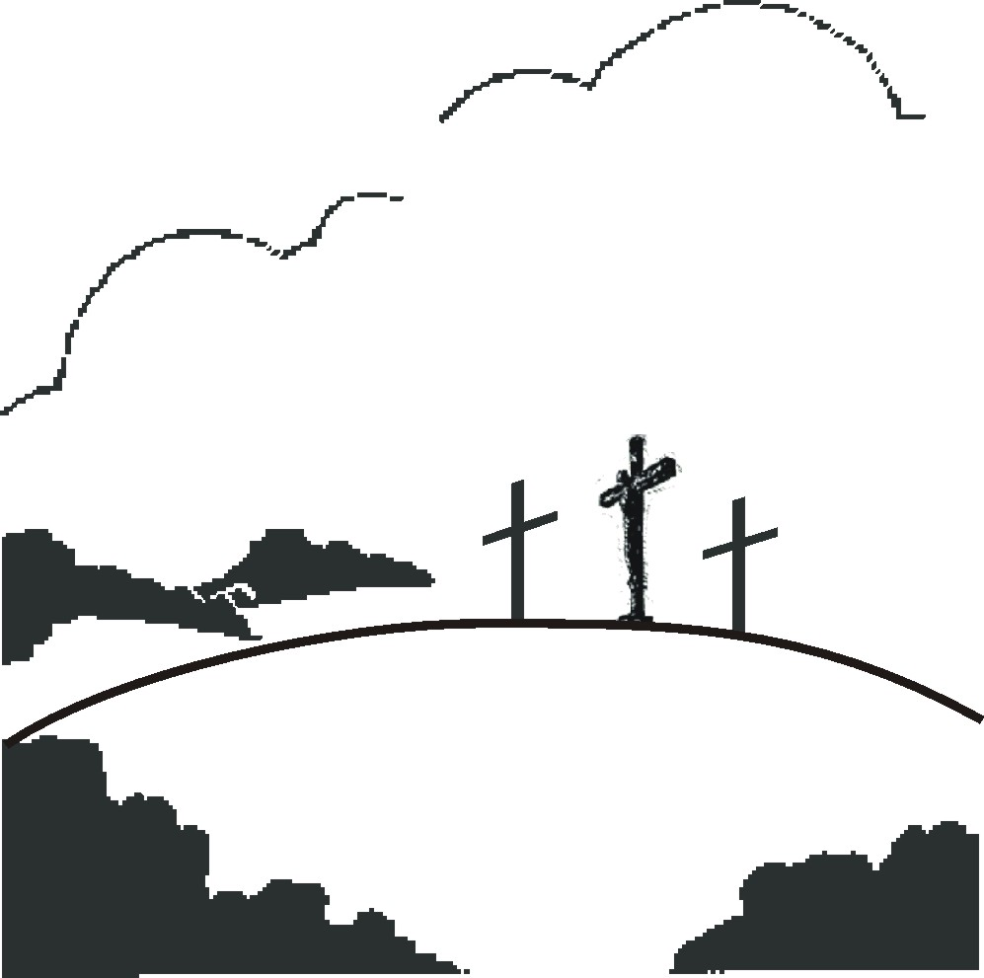
The sins of the world
Our sins

God’s punishment
2 Corinthians 5:21 For He hath made Him to be sin for us, who knew no sin; that we might be made the righteousness of God in Him.

Isaiah 53:4-6 Surely He hath borne our griefs, and carried our sorrows: yet we did esteem Him stricken, smitten of God, and afflicted. But He was wounded for our transgressions, He was bruised for our iniquities: the chastisement of our peace was upon Him; and with His stripes we are healed. All we like sheep have gone astray; we have turned every one to his own way; and the LORD hath laid on Him the iniquity of us all.

1 Peter 2:24 Who His own self bare our sins in His own body on the tree, that we, being dead to sins, should live unto righteousness: by whose stripes ye were healed.

1 John 2:2 And He is the propitiation for our sins: and not for ours only, but also for the sins of the whole world.

