CHRIST IS RISEN!

Matthew 28:5-6 And the angel answered and said unto the women, Fear not ye: for I know that ye seek Jesus, which was crucified. He is not here: for He is risen, as He said. Come, see the place where the Lord lay.
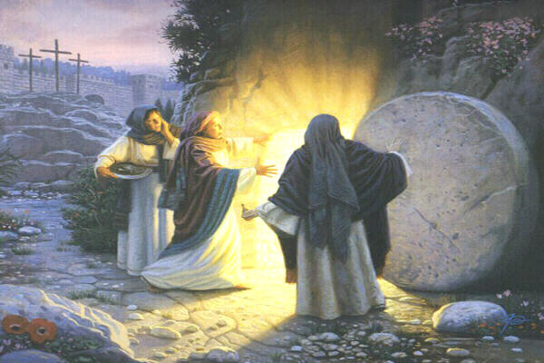

1 Corinthians 15:1-4 Moreover, brethren, I declare unto you the gospel which I preached unto you, which also ye have received, and wherein ye stand; By which also ye are saved, if ye keep in memory what I preached unto you, unless ye have believed in vain. For I delivered unto you first of all that which I also received, how that Christ died for our sins according to the scriptures; And that He was buried, and that He rose again the third day according to the scriptures:

